Avionics Interface Control Document

DOCUMENT NUMBER | RELEAS/REVISION | RELEASE DATE
BLEP-01 | NEW | 30/10/2024

CONTENT OWNER:
Jordan Gamache

Copyright © 2024 Jordan Gamache. All rights reserved.
1. Introduction 2
2. Glossary 3
3. Software 4
3.1. Software Development 4
3.1.1. IDE 4
3.2. Operational Requirements 5
4. Hardware 6
4.1. Avionics Hardware 6
4.1.1. Adafruit Feather 6
4.1.1.1. CPU 6
4.1.2. Sensors 7
4.2. Airframe Components 7
5. Payload Data Transmit Protocol 8
6. Design Specifications 11
6.1. Airframe 11
6.2. Avionics 11
6.2.1. PCB 11
6.2.2. PCB Sled and Mount 11

Introduction
The purpose of this document is to outline the specification of the design and function of the BLEP Avionics system. BLEP is an integrated modular avionics system that performs a series of operations on shared hardware. These tasks including recording sensor data, calculating state values, correcting moments of rotation during ascent, communicating over various network protocols to a “ground station”, and ejecting a parachute to support safely returning the vehicle to the ground.

The following document describes different aspects of the design, including the software and hardware designs, and outlines the network communication protocol. All decisions herein were made after significant research was conducted; however, designs improvements, hardware optimizations, and software development will continue to be implemented as time permits.

Glossary

ARINC | Aeronautical Radio, Incorporated
COTS | Commercial Off The Shelf
CPU | Central Processing Unit
DOF | Degrees Of Freedom
FCSN | Frame Check Sequence Number
FS | Functional Status
FSW | Flight Software
IDE | Integrated Development Environment
LCD | Liquid Crystal Display
PBIT | Power on Built-In Test
PCB | Printed Circuit Board
PDTP | Payload Data Transmit Protocol
RCS | Rotation Control System (a.k.a Reaction Control System)
BLEP | Big Launch Elevating the Payload
CFD | Computational Fluid Dynamics

Software
At a high level, BLEP runs compiled Arduino code, which is a variation of the C++ programming language, with some additional compiler tools that streamlines the programming of the main microcontrollers.

Software Development
The BLEP flight software is written entirely in C++, and includes a set of support header files that provide a method for flight configuration to be modified without having any impact on the core flight software. Aspects of the software environment that are used to calculate the system state, in addition to sensor baseline input values, were abstracted from the main flight software and placed in one of the aforementioned support header files. Additionally, some features within the execution flow can be enabled or disabled through the use of the support header files.

Operational Requirements
FSW-1 | The [FSW] shall provide error handling and must be capable of clearing the command queue in the event of an error prior to launch.
FSW-2 | The [FSW] shall log all data to a removable drive to support data redundancy.
FSW-3 | The [FSW] shall provide a method for pre-flight configuration and modification of crucial variables (such as SEALEVELPRESSURE).
FSW-4 | The [FSW] shall convert data to be transmitted in accordance with Section 4 [PDTP].
FSW-5 | The [FSW] shall provide the means to manually override key events during the flight plan. The [FSW] must be able to, after verifying the command was received, ignite the engine or deploy the parachutes at any given moment.
FSW-6 | The [FSW] must be able to encode and decode MD5 checksum hashes to maintain data integrity for all data (logged and transmitted).
FSW-7 | The [FSW] shall provide periodic status updates through network packets and audio/visual cues before, during, and after liftoff.
FSW-8 | The [FSW] shall be able to detect when the engine has run out of fuel (thrust ≈ 0) and must be able to independently deploy the parachutes.

Hardware
The Pathfinder avionics hardware was designed to integrate multiple COTS components onto a single board to best support the Operational Requirements outlined in Section 3.2

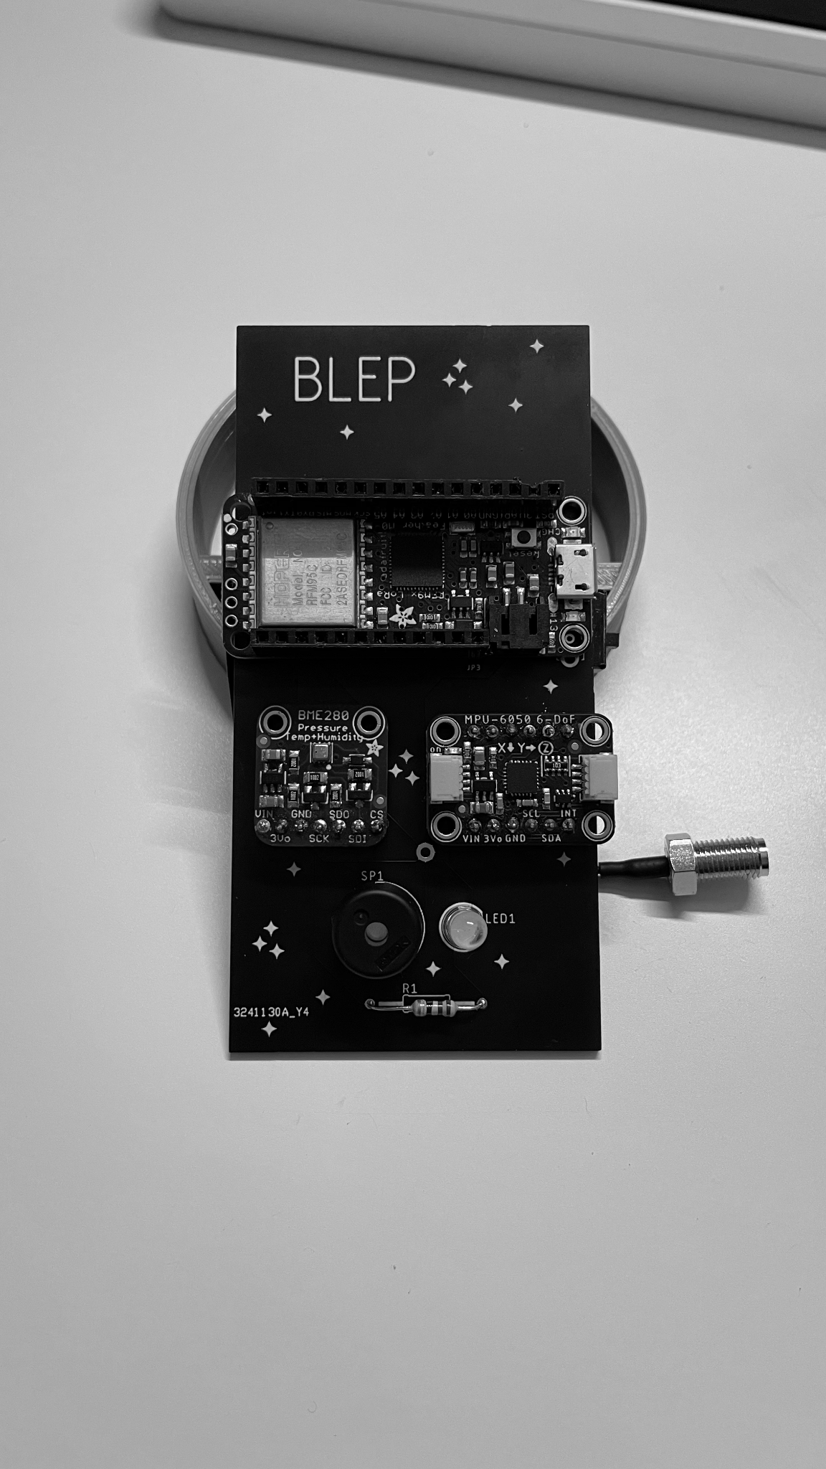

Avionics Hardware

Adafruit Feather
The BLEP flight computer is powered by an Adafruit Feather M0 with RFM95 LoRa Radio, and was selected due to its integration of the RFM95 radio chip, as well as the increased performance of the M0 processor (see next section for additional details). The “feather” is an Adafruit board format that allows for increased modularity and customization of addons in a small form factor. The selection of this particular board combines the RFM95 functionality without requiring any addons, freeing up more vertical space for additional “wings” which provide more features, such as a WiFi module, latching relay, and more.

CPU
The Adafruit Feather M0 sports an ATSAMD21G18 ARM Cortex M0 processor, which is a low-power, high-performance microchip with 256 KB of flash memory and 32 KB of SRAM. The M0 (as it will be called going forward) has six serial communication modules and built-in USB device support, and a 1.62V to 3.63V power supply. This chip has 8x more storage and up to 16x more RAM than the Atmega32u4 that was being used in the original design. These changes allow the flight computer core programming file to be much larger while also improving performance with the additional SRAM.

Sensors
BLEP utilizes two critical sensors to create a general space state of the vehicle. The BME280 temperature sensor and MPU6050 6-DOF sensor are both used in parallel to determine things like vehicle orientation, altitude, rotation, acceleration, temperature, and pressure. The discrete values are read from both sensors and stored within the code to perform any necessary calculations or process any algorithms to improve data accuracy before

Airframe Components
The vehicle’s airframe will be constructed out of cardboard tubes, but many of the mounting brackets and payload elements were designed and 3D printed using standard PLA filament. The ogive nosecone was also 3D printed using the same filament, but has not yet been tested or flown to determine structural integrity.

Payload Data Transmit Protocol
Following the approach of the industry-standard ARINC 664 data format type, this protocol is 64 bytes wide and contain a Functional Status Byte, Destination Address, Source Address, Payload, Sequence Number, and a Frame Check Sequence Number (in this case, an MD5 checksum value).

FS Byte | Destination Address | Source Address | Payload | Sequence Number | FCSN
1 byte | 1 byte | 1 byte | 58 bytes | 1 byte | 2 bytes

Functional Status Byte
The functional status byte will define the message type as either ‘INFO’, ‘DATA, ‘ERROR’, or ‘SYNC’. The value will be stored as a 4-bit binary number corresponding to the options below:

0 - INFO: Messages under this classification will provide contextual data regarding some behavior or state of the system, that doesn’t contain any data that is required to be parsed, calculated, or logged. An example of this kind of information would be console logging output from the [PBIT].

1 - DATA: Messages under this classification are directly related to avionics reporting and are the “highest” priority data. Type 1 messages contain sensitive payloads required for calculating vehicle state, performance, and other values. Transfer of Type 1 data supports a valid “telemetry” system, allowing a remote machine to receive avionics data payloads. An example of this would be in-flight transmission of yaw, pitch, and roll values for the [RCS].

2 - ERROR: This is the second most “important” Type of message, as any time prior to engine ignition, the system must be configured in such a manner that any Type 2 error completely cancels the current task, sets the vehicle into a standby mode that requires user input or a manual reset before proceeding with a launch. Failure to properly configure the system in this way may result in catastrophic conditions before, during, and after liftoff.

3 - SYNC: This data type will simply provide a constant “ping” to confirm telemetry uplink communication is still connected. The payload for a Type 3 message can realistically be anything, as the data will be discarded entirely unless the “DEBUG” flag is set to true.

Destination Address
This is a simple field to designate the flow of network traffic. Values of 101 indicate that the intended destination of the data packet is the ground station, and values of 100 indicate that the intended destination of the data packet is the vehicle itself.

Source Address
This is a simple field to designate the flow of network traffic. Values of 101 indicate that the source of the data packet was the ground station, and values of 100 indicate that the source of the data packet was the vehicle itself.

Payload
The data payload must be exactly 58 bytes, regardless of the size of the data contained. If the data contents do not reach the 58 byte size, a byte padding will be implemented and discarded upon data packet receipt. The format for the payload is as follows:

Byte | Description | Data Type | Bytes (Maximum)
0-4 | Temperature | float | 4
4-8 | Pressure | float | 4
8-12 | Altitude | float | 4
12-16 | Humidity | float | 4
16-20 | Yaw | float | 4
20-24 | Pitch | float | 4
24-28 | Roll | float | 4
28-32 | Accel_X | float | 4
32-36 | Accel_Y | float | 4
36-40 | Accel_Z | float | 4
40-44 | Yaw_Correction | float | 4
44-48 | Pitch_Correction | float | 4
48-52 | Roll_Correction | float | 4
52-58 | Pad | TBD | 6 bytes
Note: 4 bytes = 32 bits; 8 bytes = 64 bits

Each data point will be converted into IEEE-754 Single-Precision Binary as described in the table above and sorted within the data message “word”.

Sequence Number
The payload sequence number is a sequential number ranging from 0-255, and is entirely for data integrity analysis purposes. The sequence number will reset after reaching its maximum of 255, and a sequence reset will be logged.

Frame Check Sequence Number
The Frame Check Sequence Number is a data integrity/validity check that will be calculated on the ground and vehicle sides in order to ensure that the data received was not corrupted during transmission. The use of an MD5 checksum will be implemented on the payload data only for simplicity. If increased data integrity checking is required in the distant future, entire packet checksums can be generated, but at this time that is not required.

Design Specifications

Airframe
The airframe of the vehicle has not been constructed at the time of writing this document, but multiple designs have been compiled and the latest model will be linked below. To be considerate of cost factors, the airframe will not be built until all simulation and testing has been conducted, the results have been analyzed, and an efficient design has been confirmed. At this time, CFD simulation testing still needs to be completed to determine if the current nosecone and fin measurements are optimal.
BLEP.pdf

Avionics
The avionics system has completed three rounds of revision, starting as individual components connected to a breadboard with jumper cables, to a proto-board, to a custom PCB.

PCB
The BLEP PCB was designed over multiple months, and still some errors occurred with routing. The design that was used failed to connect one of the MPU pins to the correct sampling pin on the CPU feather, resulting in the need for a manual override. The erroneous traceroute was cut on the silkscreen to damage the connection, and a jumper cable was attached to the correct, exposed pins. No damage to the sensors or board has been detected yet, and both seem to be functioning as expected. If future errors arise as a result of these pins, a new PCB may need to be designed to correct this issue, however, the BLEP project is not large enough to warrant the expense at this time.
FlightComputer-PCB.png

PCB Sled and Mount
The PCB sled and corresponding sled-to-airframe mount were both custom designed and 3D printed using measurements of both the fabricated PCB and the acquired airframe tubes. Some holes will need to be drilled into the mounts in order to securely mount the avionics bay to the airframe. If the mount itself does not respond well to being drilled through, new parts may need to be fabricated to include properly bored screw mounts.
Sled Plate.pdf,
Avionics Payload Mount.pdf

